**Conversation Guide: Digital Health Modernization Discovery Research**

**Bold text identify the moderator’s questions.**

*Text in italics are Jen’s observations and interpretations of the participant.*

[Text in brackets are interpretations in participants’ direct quote.]

**Background (5 minutes)**

To get started, I’d like to get a little background information about you, and your experience with the VA.

1. **Can you tell me a little bit about yourself?** **You said you left the Coast Guard in 1993:**

21.5 years and I am retired.

I am in Salisbury Maryland.

**What do you do in your free time:**

Now, I just hide out from COVID. Participant laughs. I hate to say that. But there’s a percentage that doesn’t believe there is a pandemic, and then there are people that think there is but I will still do what they want to do. My wife is a medical tech that works in the lab at the local hospital. My daughter, I have two daughters, she is a Lieutenant in public health service for the Atlanta CDC. But she is also a virologist and a vet [veterinarian]. She has been a with the commission corps for 3 years. Graduated from VA tech. Spent her whole 10 years at Virginia Tech.

I catch a lot of grief from my wife from wearing the mask and doing the 6ft thing. I just got done deer hunting and the guys I hunt with are from the left [politically] that know there’s COVID but don’t wear masks unless they are inside the buildings. They still have their parties. I wear my mask around and they don’t have a problem with it. I do my thing and they do theirs.

My oldest daughter is adamant about wearing masks and the N95 is the best one to wear. My daughter is deploying through the US for the COVID stuff.

Most of my career was with drugs, and interdiction of drugs. I can see them coming but COVID you can’t. I’m sorry I ramble. *Chuckles.* Cut me off, I ramble.

**You said your career was with drug addiction. Did I hear that right?**:

No, interdiction, drug smuggling.

When I retired or 3 years before, it is a duty station no one want to go to except if your from a big city. It was Governors Island in New York City. But it was on an island where they do the big ships and the smaller stations But from the Mississippi River to the East Coast. An from Canada over to the Caribbean was ours. We taught them the new boats, new crews, get them cohesive enough so they could go out and stumble into something but not get killed.

**What prompted you to join the Coast Guard:**

I was born in Camden North Carolina, and across the river the biggest Coast Guard air base in the world. My dad was civil service there, he was a comptroller.

At first I was going to go into the Marine Corps because a lot of my friends were being drafted. Because that was during the draft. I kind of thought of myself more of a Marine. I was always on a boat fishing or doing whatever and it just didn’t seem like a job. You’re having fun in a boat.

My dad said talk to a Coast Guard recruiter and if you want to go to the Marines then go ahead but you might go to Vietnam. I [his dad] don’t even know if the Coast Guard is in Vietnam. Turns out they were but 72 was winding down, so a lot of the Coast Guard was coming back.

I joined the Coast Guard, there were times, it’s like any job where there are highs, lows, and the middle of the road. I had more highs then lows.

The one problem I had, I waited until later in life to get married and we’ve been married for 38 years. The military is not forgiving when it comes to wife and kids. In the old Guard if it didn’t come in the seabag it doesn’t come with you. It’s changed tremendously now. I talk to some of these new coasties and they can take their wife to restricted duty. Back when I was in it was you and 10 other coasties. Now you take your wife and kids!

I was in NY for the first World Trade Center bombing. Actually I was coming out the right door to be coming out in the Trade Center when the bomb went off. We had just came out from a meeting with the DEA and it was a short walk back to the island. So you know you don’t drive in NY. We were going to get something to eat and it let loose and I was like holy cow. After all of the dust settled and got all our dress uniforms were all nasty. We got back to the island and I called my wife. She asked when I could leave there, only way I was going to leave was to retire, I was supposed to be there for about another 2 more years. And I was like do I really want to stay in New York City. At the time I was 42 as I look back, at 42 I was still young, at least my thinking was. So put in my papers and I retired effective June 1, 1993 and moved back to sunny Chrisfield.

Then I started another career in law enforcement.

1. **You said you’re not receiving anything from the VA at this time:**

It was banged into us, even by the corpsmen or health services, they says you are so lucky. You can get VA benefits when you retire. Back in 93 there wasn’t a lot for the military as at whole besides the Army or Air Force. They at least old you about the benefits and how you would get them.

The Coast Guard was one of the last of the uniformed services to actually, they took the bearing that, you want to leave us then to hell with you. You retire and you don’t hear anything.

The VA moved from one building to another and no one knew where it went. And of course when you call the 1800 number they tell you that the office closed, and it moved and closed. I know there’s a VA in Salisbury but that was in 96-97 just before I changed law enforcement jobs.

There was always a question about the state in Maryland is a weird state. I hadn’t retired and I had 15 years with a military outfit, I could get up to 5 years of that the military time added to my state retirement. So that’s great but I had retired. Initially I was told I would get 5 years whether you retire or not. So in 2017 I was forced to retire and I put in for the extra 5 years because it was in the form. Within minutes they told me I didn’t qualify because I retired.

Then I called around the other states and they don’t care if you retired you get your five years. Maryland is very persnickety, they doesn’t want to give you more than you should.

The VA was the same way, when I finally found the VA they said I couldn’t just walk in I had to make an appointment. Ok how do I make an appointment? Oh you just go on the webpage.

So I typed in the VA, I put in all my information. I was never routed anywhere but I received a nice letter from them telling me I make to much money. I got so angry; I have the paperwork somewhere I just said the hell with you too.

So everything I have done for health care and retirement was through the state of Maryland.

I met the secretary of the VA of Maryland at a Popeyes when I worked as a police officer. He said, do you know who I am? I looked at him and was like he could be a suspect but we will see how it goes. I was like VA Virginia? He said no of the Veteran, he said let me buy you dinner. I said no, I never took gratuities on the road it could only get you in trouble. So I said let me buy you dinner and he said okay.

He talked and confirmed the deal with the 5 years with the VA. He said I should be getting VA benefits. He asked what the problem was, I told him, and he said that was changed in 94-95 by Congress because of income level but that’s going away. I told him I applied and made too much and he said he thought they were wrong. So now I’m getting conflicting information. He represents the VA so I reapplied and I am still waiting. That was about 20 some years ago and I still haven’t heard from the VA. *Participant laughs.*

I’m live on their webpage. I have their password but I don’t really go on it.

When I left the Coast Guard I retired and went to the local sheriffs office to be a crime scene tech. And then I left them in 98 and went to the state of Maryland Natural Resources police then went to be a conversation officer. When we were in the academy, it gets a kickback for training.

In other words the VA pays, it’s like the GI bill, but it pays for on the job training for the person. There was like 6 of us that were veterans. It seemed like two the guys that were minorities, they actually got checks they could cash from the VA. We were 14 weeks in before I we got a paycheck. The state messed up so we just didn’t get paid. At the time I went to my Sergeant, I asked why are they getting paid, why we weren’t getting paid. He didn’t know so we called the VA and they didn’t know either. I said I guess non-minority we were just screwed so we sucked it up and got on with it. We eventually did get paid, but they were a little slow.

1. **You said you went online to apply for VA benefits:**

The old GI bill is gone so I am screwed in that deal because I didn’t go into the Montgomery, when you could’ve been able to go for free for the rest of your life. Its all changed now. We didn’t pay anything into in. It was just our benefit of going to college, I knew several people that came back from Vietnam and some of them going to college for 6 years and still getting paid by Uncle Sam so they got college stuff. I wanted my degree, when you have a family of people with degrees and you’re the only one without it, you kind of feel bad about it. The GI bill went away. Even the local college here, 2 year, I did not qualify. I told them I came in 72 and retired in 93 so that went away. Oh that’s gone away.

The only thing I benefited from the VA that I think we got was the GGIi bill for housing. We bought a house in Crisfield when I first retired. I don’t know the interest rate but it had a lot better ones so we went with the VA.

I haven’t missed out; you can’t cry over spilled milk. I belong to several Facebook Coast Guard groups and some of these guys are trying to get their disability.

I didn’t get a disability from the Coast Guard but my knees are shot from beating and banging in the boats. But then again I also spent 19 years with Natural Resources police beating and banging in boats as law enforcement.

Nobody can find the health records from there. Back then you had to write a routing slip for a copy of your health record. But I thought they would just send it. Well that was wrong. Besides my retirement I don’t exist in the Coast Guard. Every time you call the VA they can’t find a record of me. I guess it was just a dream. *Participant* *laughs.*

**You said you have password for VA site:**

Yeah let me make sure, at my age I have to write everything down.

In police work got toughbooks for our cars to mainly help write reports then it ended up writing tickets. 123456abcd doesn’t work. Simple mind, simple job, but the serial number there but that didn’t work.

I know I have the VA thing in here somewhere.

**Can you tell me are you looking for:**

It’s funny because when I retired from police work I did the 4000 honey dos that I told her I couldn’t do because of work. So took off about year, so 2018 I was a bum and was here painting. I finally figured out I had to do something and my wife wouldn’t give me much money, like I say I hunt so I needed a job. All that costs money so I got one with the city for a parking attendant. It was low speed low drag. I got in a couple fights over people arguing over $2.50.

So I may not have it. I’ve got everything else. Social Security. *Participant is shuffling papers.*

**Could you show me the website the website you’re looking at. You don’t need to login:**

Ok.

*Moderator walks participant through screen sharing.*

1. **Can you show me how normally look up things on the VA:**

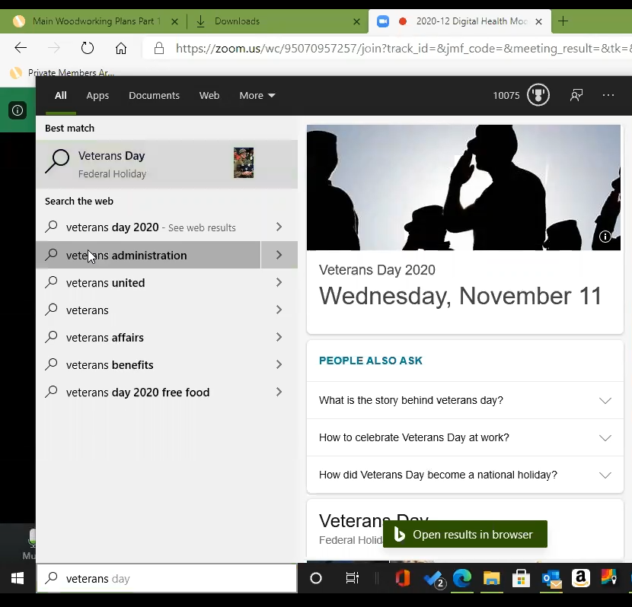

*Participant uses taskbar on Windows computer to search.*

*Enters in “veterans” and clicks on “veterans administration” in results.*

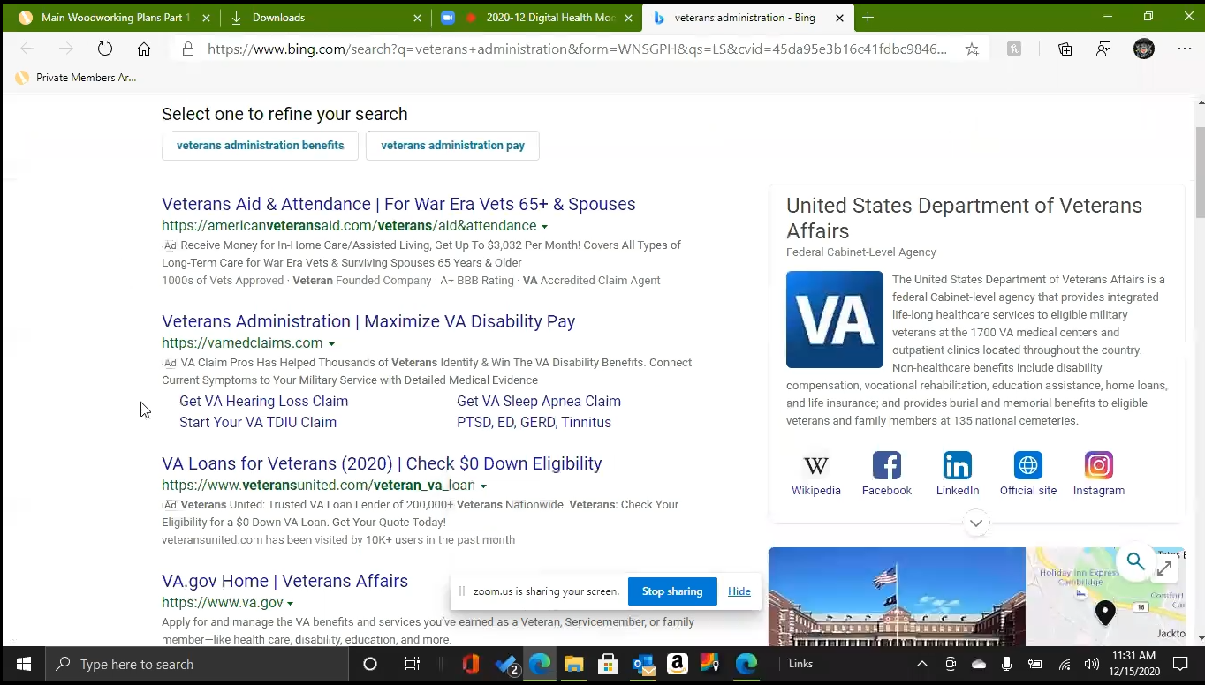

*Participant’s search results.*

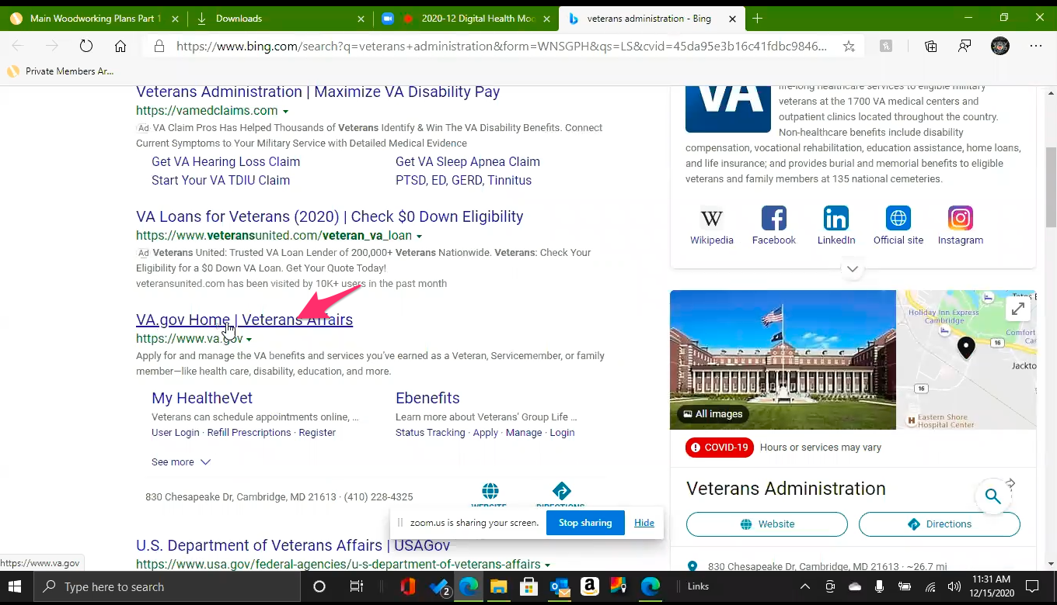

*Participant scrolls down and clicks on [VA.gov](http://VA.gov) link.*

**So this is the website you use to find information:**

Yes.

Information, just whine a little bit maybe because I am trying to figure out what our benefits are.

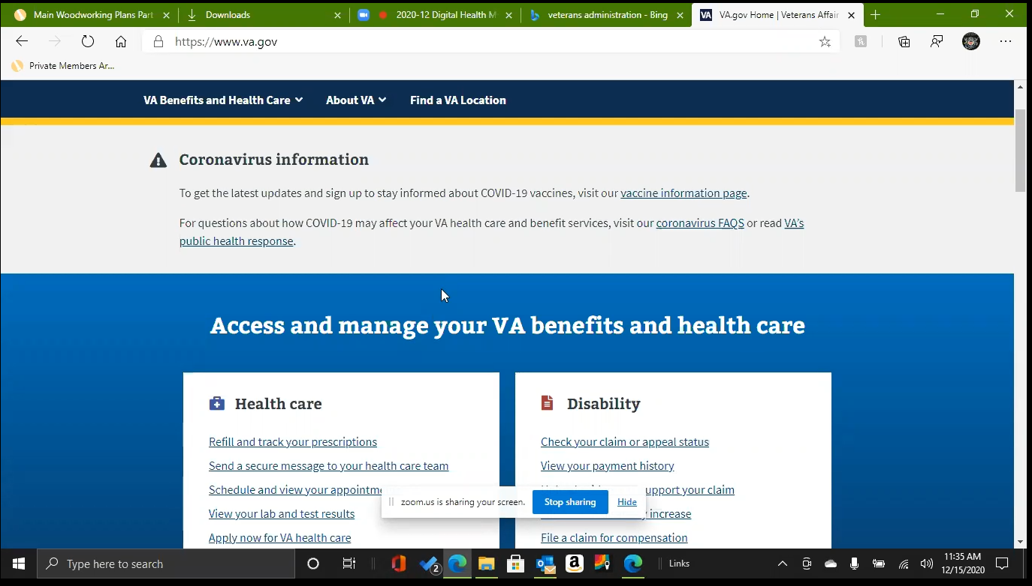

*Participant up and down the page while talking.*

I tried to do the education side but the VA is very regimented if you qualify or not. If you don’t you don’t get it. The take on that is that I should have taken it, I think it expired in the late 70s or early 80s. I had a wife and kids I couldn’t just take off and go to college.

1. **What do you use this website for the most:**

I can’t even find the stupid password. I haven’t been on it for several years.

I ran into a guy that worked at the VA while working as a parking attendant and told him what was going on. He said you just need to make an appointment and we will fill out the form. You might not be making as much as before so you might qualify for all the VA benefits. And then COVID hit and I haven’t been back since.

1. **Is there any VA benefit you have or would like to apply for:**

No. The only one was for college but you just can’t work around it. You either qualify or not and I don’t I qualify.

I’ve tried to look into medical, you know like prescriptions, because I have my health insurance through the state and now I guess the retired state employees have a lawsuit against the state because they are going to in 2022 quit paying for out health benefits.

**The state of Maryland:**

Yes, right now we have a stay in court.

I am a vet I should get my prescriptions at least.

Most of the VA on the eastern shore. I know 30 minutes south then the rest are across the bay and I really don’t like going across that bridge.

Can I get out of this or do you need to stay here?

1. **Anything on this website you've looked at before:**

I tried to refill and track prescriptions. *Participant hovers over “Refill and track your prescriptions” link on page.*

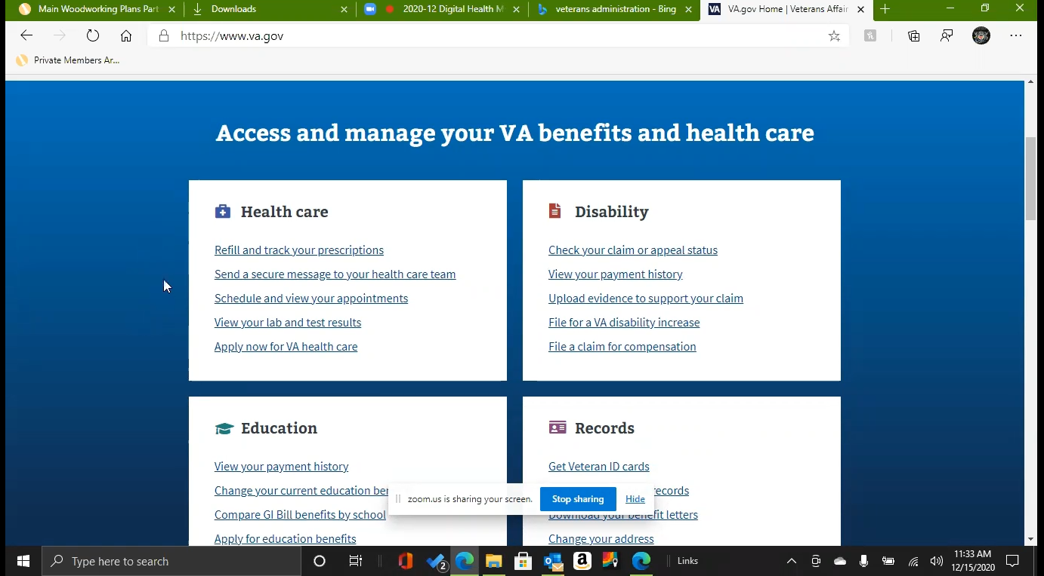

*Participant’s screen during this section. They seem to be mostly reading and responding to links on this page as opposed to going off of memory.*

I don’t need the Veteran ID card because I have my military retirement card. *Participant hovers over “Get Veteran ID cards” link on page.*

I’ve tried to access. *Participant hovers over “Get your VA Medical records” link on page.* I mean I have copies of my DD-2-14, through the Coast Guard side.

I have tried the healthcare, disability and education, and records. *These are the four sections on the page.* I have gone through all of them just to see if I qualify for anything.

It basically boils down that if you don’t have a record as a vet, which right now I punch in both my SSN or my old military id number, and it just says no records. I am just like okay. *Participant chuckles.*

I usually just get out of it out of frustration.

1. **Under disability have you formally applied for with the VA or more just done research:**

More research because I cant find my health record. I am sure the VA won’t take my word for it because it’s the government. Not having a record, I mean health record anyway, puts you at a serious disadvantage. At 69 I pretty much said that’s the way it is.

*Participant seems to get defeated as conversation goes on.*

I know I have a doctor I have seen for the last 25-30 years. I guess the office he was attached to before he left and they were doing VA exams. He said lets talk to somebody about you getting exam. And then he left.

I saw him 6 months later and asked him if he got anything from the VA and he said no not really.

*This is the third time the participant has referenced a VA adjacent person suggesting he should be getting benefits, offering to help take care of it, and then nothing became of it.*

*Participant stops sharing screen and asks to get out of VA website.*

1. **So you are not getting any VA healthcare:**

No.

1. **Who provides your healthcare:**

The state of Maryland and it is Blue Cross Blue Shield.

Express Scripts for prescriptions.

Then Tricare for life but that’s like the last thing in the world. I am not sure what they cover because normally it is denied.

Medicare is primary, Blue Cross is secondary and then Tricare is last. God forbid anyone puts them above last; it is an automatic we don’t cover that. *Participant laughs.* Ok.

**If they put Tricare before your Blue Cross Blue Shield:**

Yes, it is almost like someone is standing up there with a hammer saying no.

I just saw that Tricare is making the active duty, or the younger military, pay something a month when it use to be free.

Now the Coast Guard cant use their allotment system to pay for this because of interaction.

I have talked to a few folks that just retired in their 40s, and they say you’re getting free medical. I say yeah because I worked another 19 years for the state.

**What about your wife is she on the same insurance:**

Yes, she is. Well she is not on Medicar. She is just Blue Cross Blue Shield and my insurance from the state.

I don’t think Tricare has anything to do with her and Medicare doesn’t want to have anything to do with you.

**Is the insurance you get through the state, the Blue Cross Blue Shield**:

Yes.

**Did that kick in in 2017 when you retired**:

Yes.

1. **When you make a regular doctors appointment, how do you do that:**

I have a general practitioner that I see and a cardiologist.

They already have the paperwork. I have been going to both for so long, typically just bring your cards and the pills you take. I don’t have to do that anymore because they have seen me for so long.

Normally it is just call.

I have been cancelling my eye, cardiologist, and general practitioner appointments because I am just worried. Last time I went to the general practitioner the nurses in August they didn’t have a mask. I guess I was being a smart ass, I asked then they put them on. I don’t know its just weird. Everybody’s got their own ideas so I just stay at home.

That's normally what I would do just call and they take my Medicare and I think that’s where the Tricare for life kicks in. Tricare for life pays the deductible. I think that’s how it works.

**You would call to set up and appointment:**

Normally, except the last one I cancelled. I need to make the ones for next year.

I see them every 6 months unless is have issues. I am waiting to see what happens before I venture out.

1. **Do you use any websites to manage the general practitioner or cardiologist appointments:**

I am kind of lucky now the medical hospital here, they change their name to Tideland PMRC. I don’t know what. My family doctor and cardiologist are all under them so I have the password and its in the computer. HealthNet I think it’s called.

*Participant seems to be reading off of papers they had earlier that had login information.*

The HealthNet website. Oh and I do I have the VA. I think the VA is Health Vet password. I just looked at it and saw Health Vet. I’m afraid that password is so old. It’s probably really old. Let me have a second now that I know what I am looking for.

*Participant reads to self for a few seconds.*

Are you a graduate student or employed by however or a think tank? I don’t want to hurt your feelings or say something stupid.

*Moderator responds that they are working for the VA and another agency called US Digital Service to try to improve digital services.*

I had three friends when they retired they went on to do backgrounds investigations for the government. I guess they shut the program down, but he was in Detroit, Indianapolis. I was doing background before I was retired. I guess the government does per diem. You make your own travel and they pay you back. Like the military pays for you. You know.

That’s the only thing I have. I mean I can show you what I got.

*Participant shares screen again.*

I’m assuming it’s the same. I’d hate to use. *Participant seems to be thinking about how they should find the My HealtheVet site and if it is the same as the* [VA.gov](http://VA.gov) *site.*

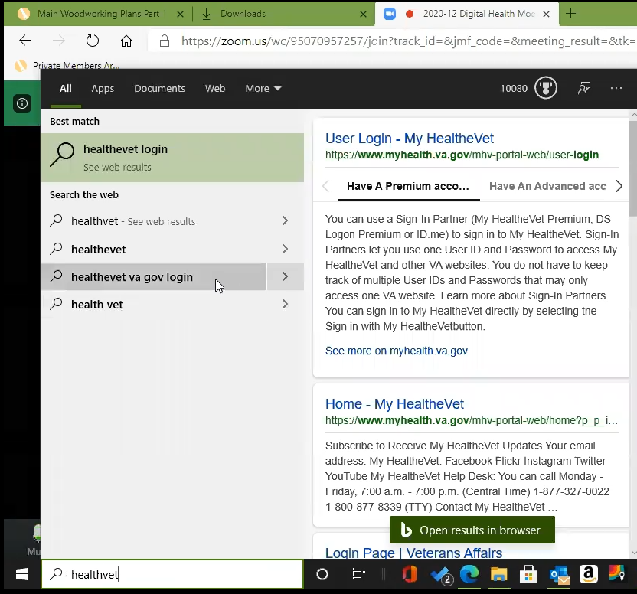

*Participant types in “healthvet” into Windows taskbar search. Clicks on “healthevet va gov login” result.*

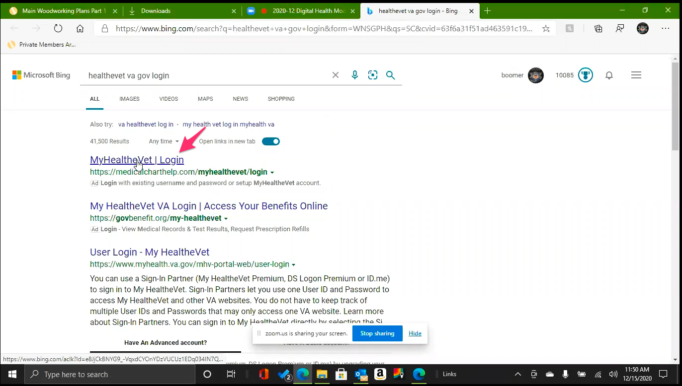

*Participant's search results page.*

*Participant looks at page for a few seconds and then clicks on the first result link which is not My HealtheVet website but reads like it is.*

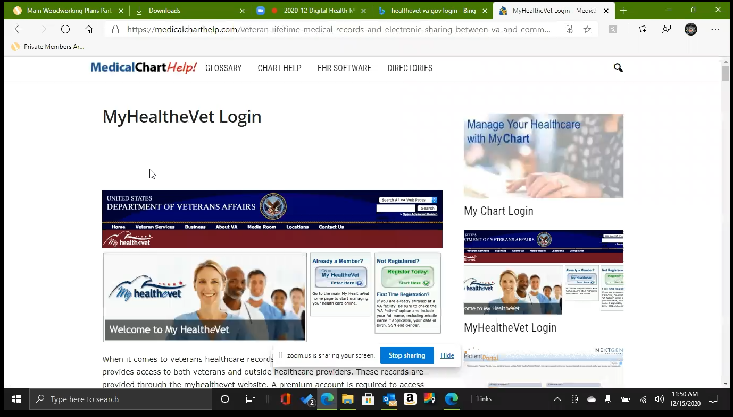

*Website from search results. Participant is immediately confused but isn’t sure why.*

*Participant audibly sighs and scrolls up and down the page.*

**Is this what you were expecting to see:**

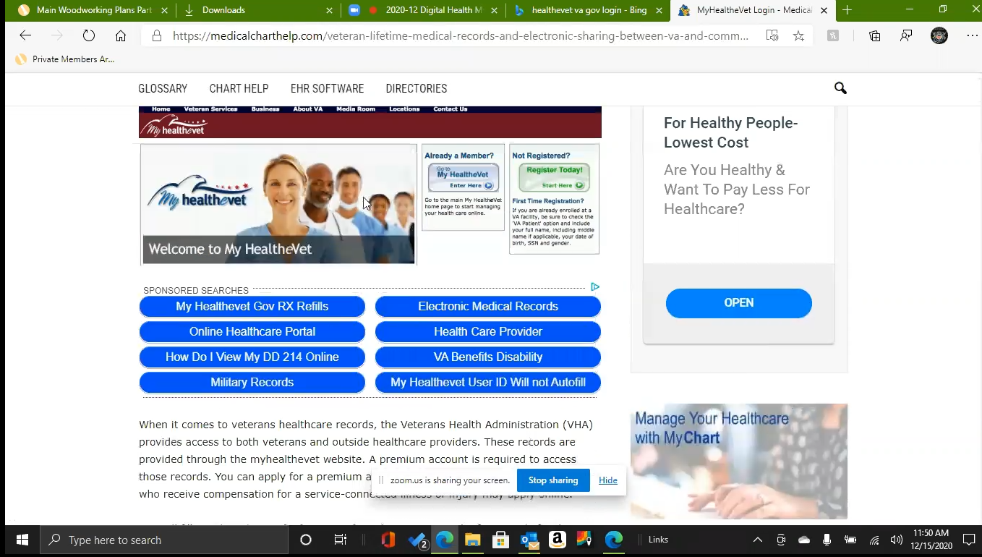

*Participant continues to scroll up and down the page.*

It’s been so long that I have been in here, I don’t know what I should see.

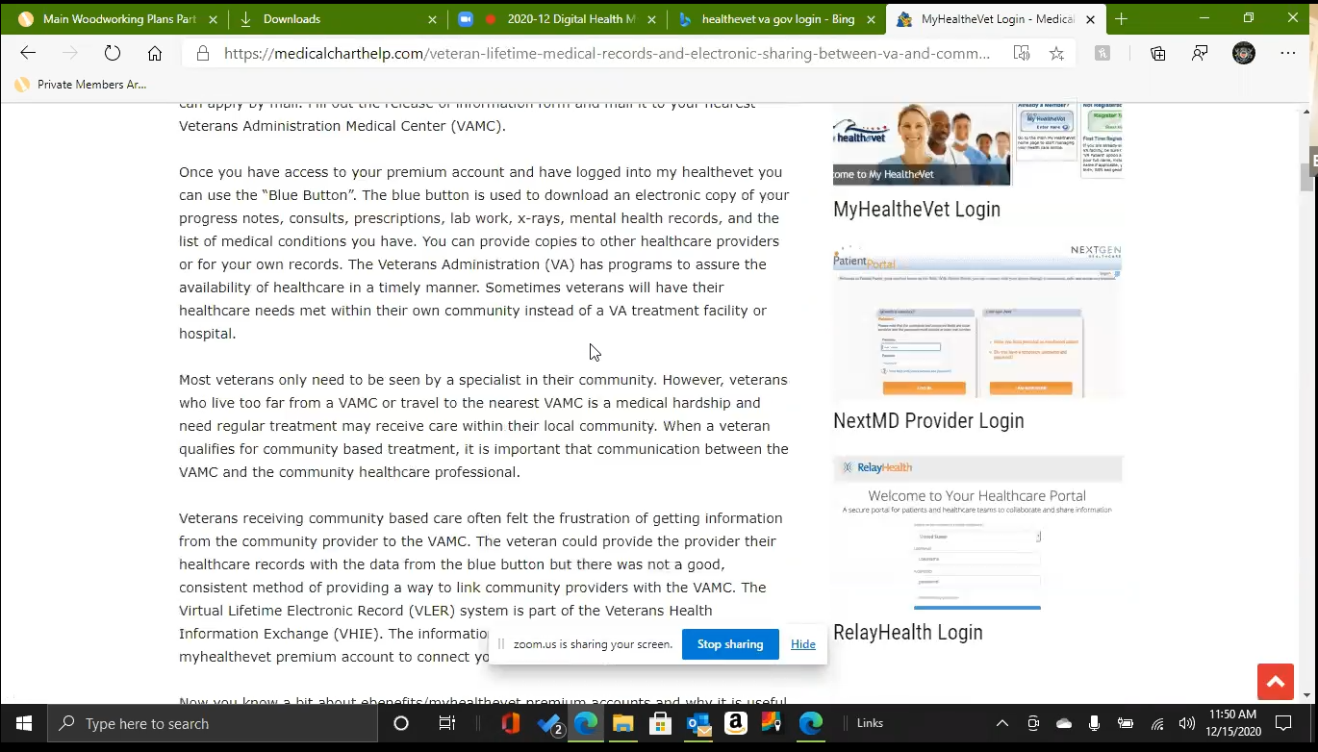

*Participant continues to scroll up and down the page.*

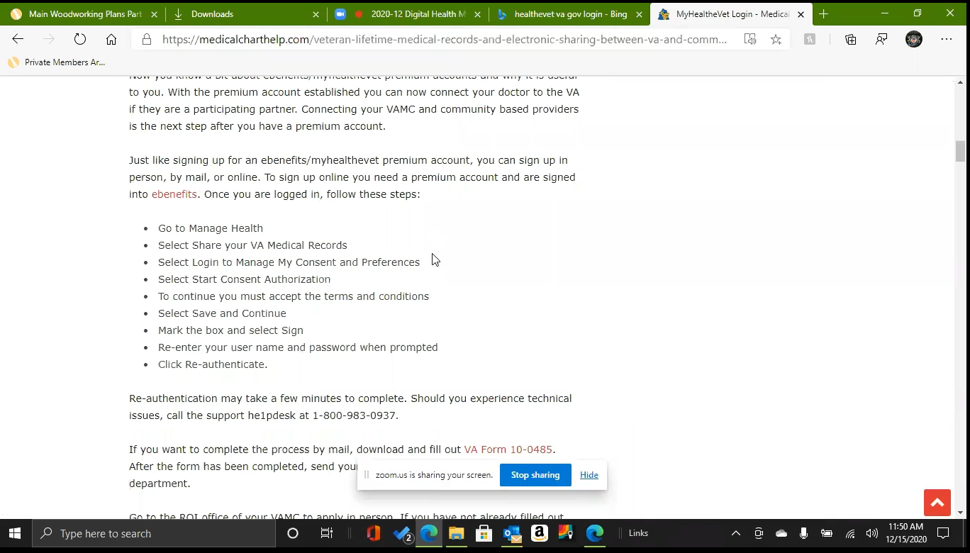

*Participant continues to scroll up and down the page.*

I don’t even see where I can sign in here. Uhhhhh.

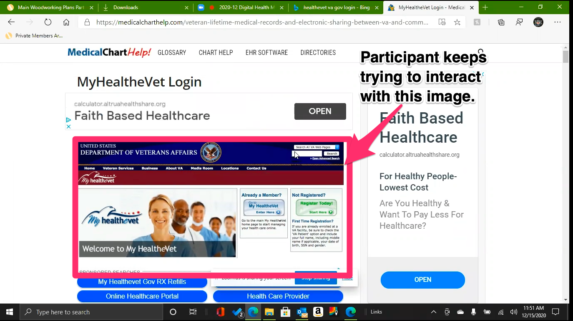

*Participant scrolls back to top of page.*

*Tries several times to click on and interact with screenshot of screenshot of (old) My HeatheVet website. Especially the search box area. Doesn’t realize it’s an image.*

I mean there’s something there but it.

*After several clicks on image at top of the page participant scrolls back down the page. And back up. Repeats several times.*

It doesn’t actually come up with the… ummmm.

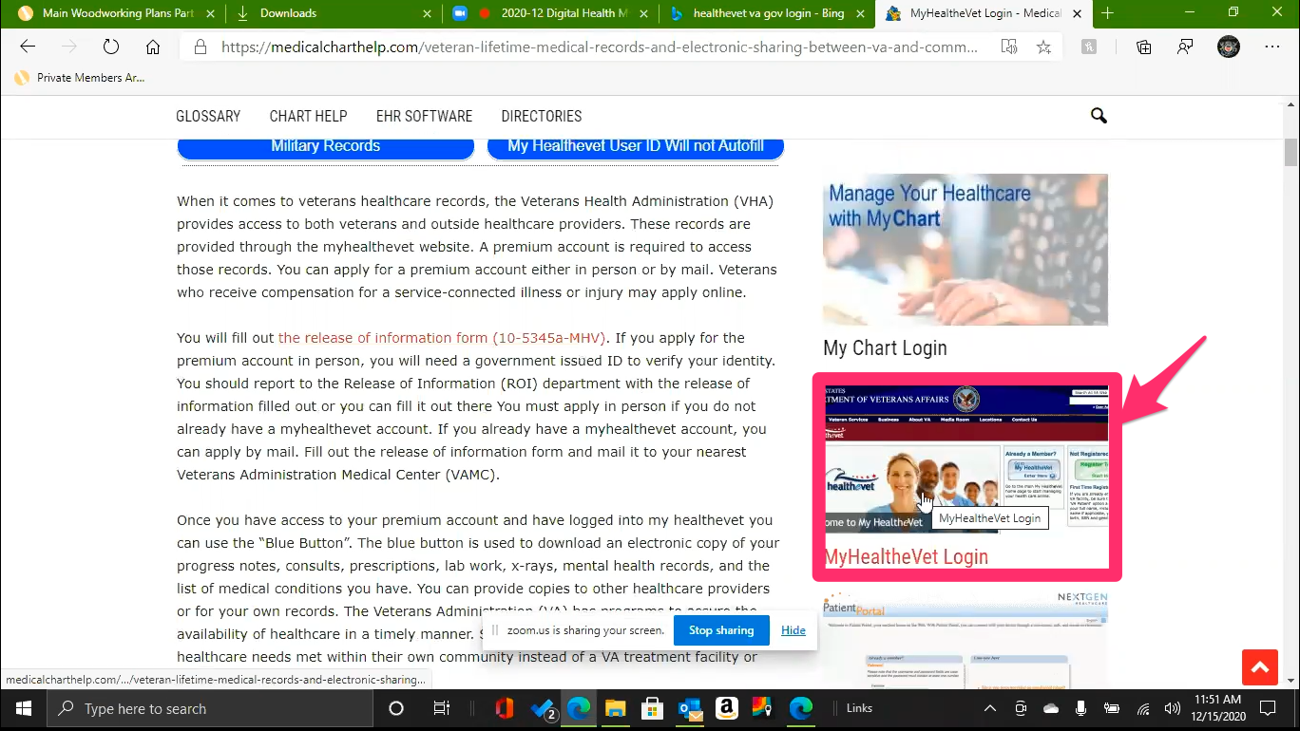

*While scrolling participant sees same screenshot image of (old) MyHealthe Vet website in sidebar with title of “MyHeatheVet Login”. Participant clicks image.*

Maybe it’s here. I don’t know. Let me try that.

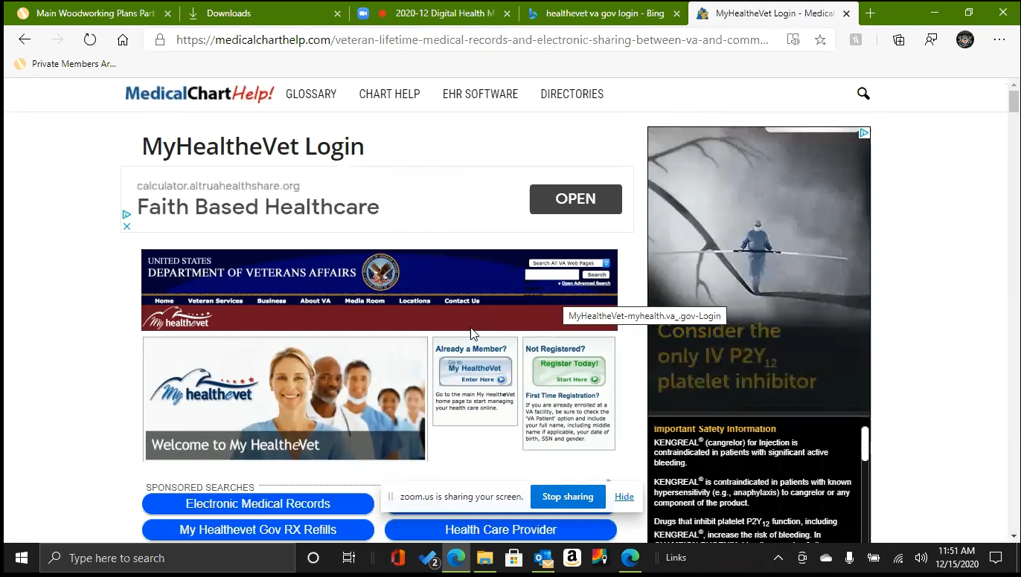

*Image was linked to page participant was already on.*

*Participant audibly sighs when it loads.*

Well that’s not it.

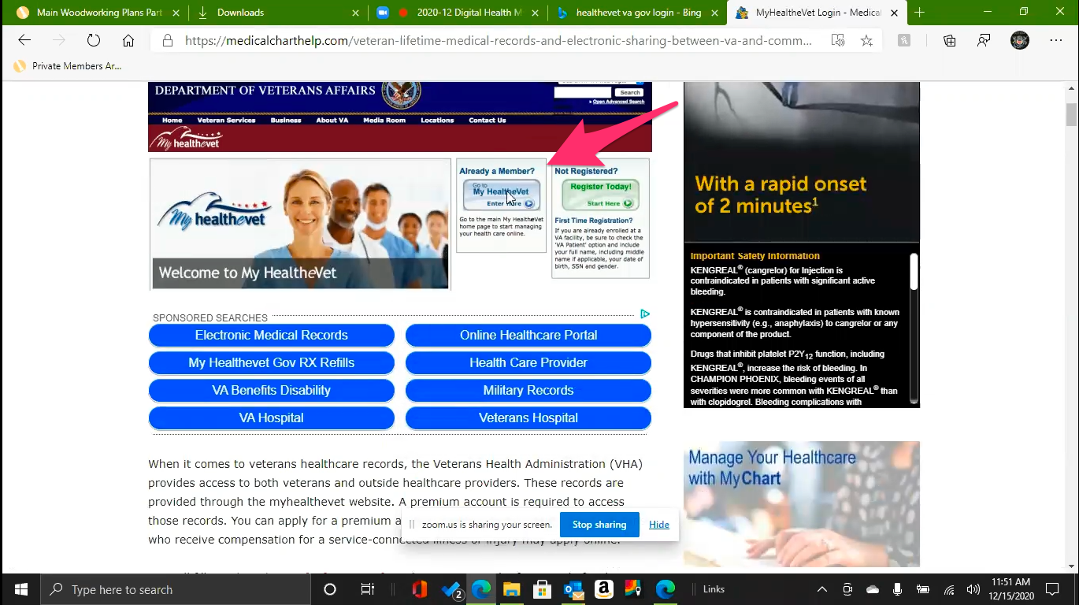

*Participant tries again to click on screenshot of image of My HealtheVet website. Specifically the "Already a Member?” section.*

*Participant scrolls down the page again.*

I’m not really sure where you would put in anything. I mean you go over here to my health vet login. *Participant is referring to sidebar image link he just clicked. Clicks link again. Page reloads.*

This. I don’t know*. Participant is frustrated and confused.*

The sign in page comes up but I don't know. I think it’s just. *Participant is referring to top image screenshot of MyHealtheVet site he’s been trying to interact and click on.*

*Participant scrolls down and up the page again.*

I mean you can’t click on anything.

*Participant scrolls down and up the page again.*

I’m open to suggestions.

*Participant scrolls down and up the page again.*

**Maybe lets go back to the search and try again and see if something is there:**

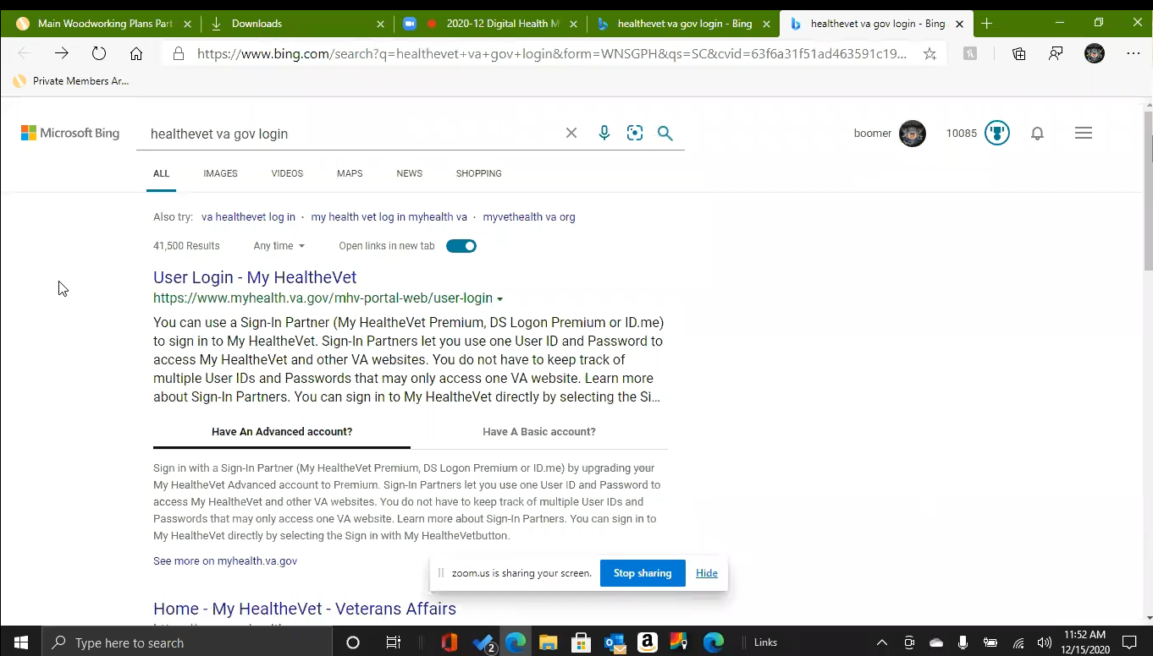

*Participant uses back browser button to go back to Bing search results. I am not familiar enough with Bing to know why these results appear different then the last time they viewed them.*

I don’t do this very often.

They have portal so that’s always a good one.

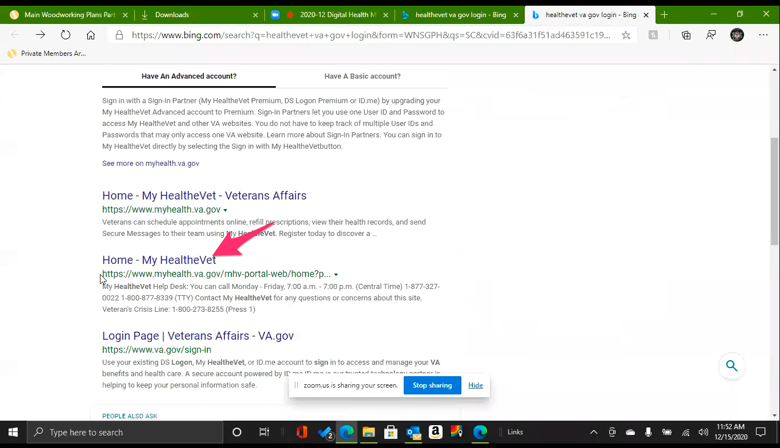

*Participant scrolls down search results page, sees the word “portal” in the url, and clicks the link to the my[health.va.gov](http://health.va.gov) site.*

They have portal so that’s always a good one.

Sign in.

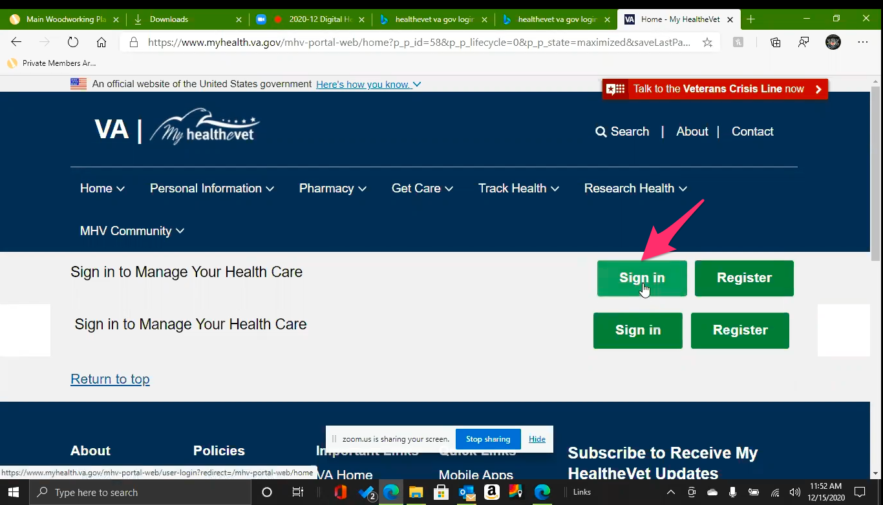

*Sign in page from search results. Participant looks at the page for several seconds and wonders why there are two sign in sections. Participant clicks on top green “Sign in” button.*

What’s the difference. *Participant is referring to the double sign in sections on the page.*

**Have you seen this page before:**

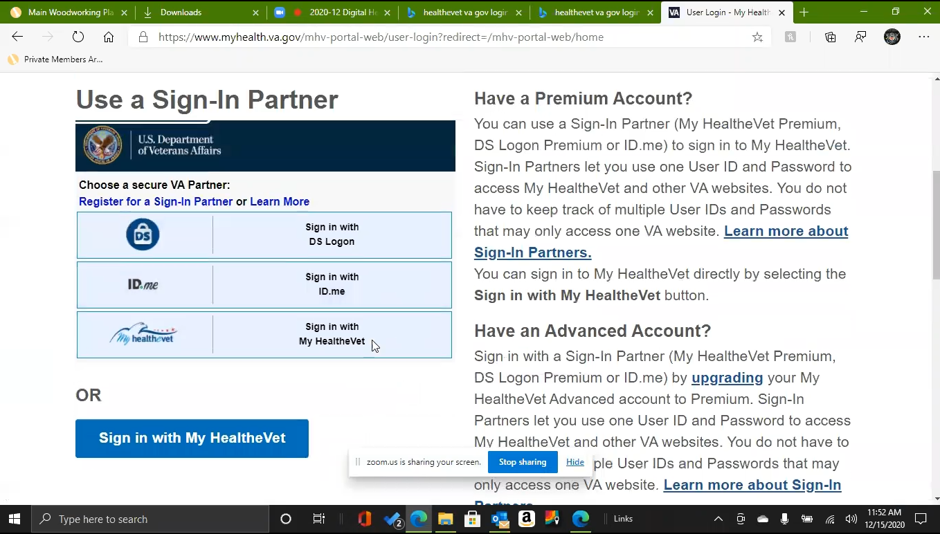

*Sign in page on participants screen.*

It's has been awhile, but I don’t think I have seen this before.

Use a sign in parter. *Participant is reading the page.*

I don’t know what a partner would be.

Oh ID Me. Maybe that’s the thing. I am assuming that its been awhile. And I’m trying to look at my, I have my name down but not a password.

But I know I am live on the sign in for ID.me.

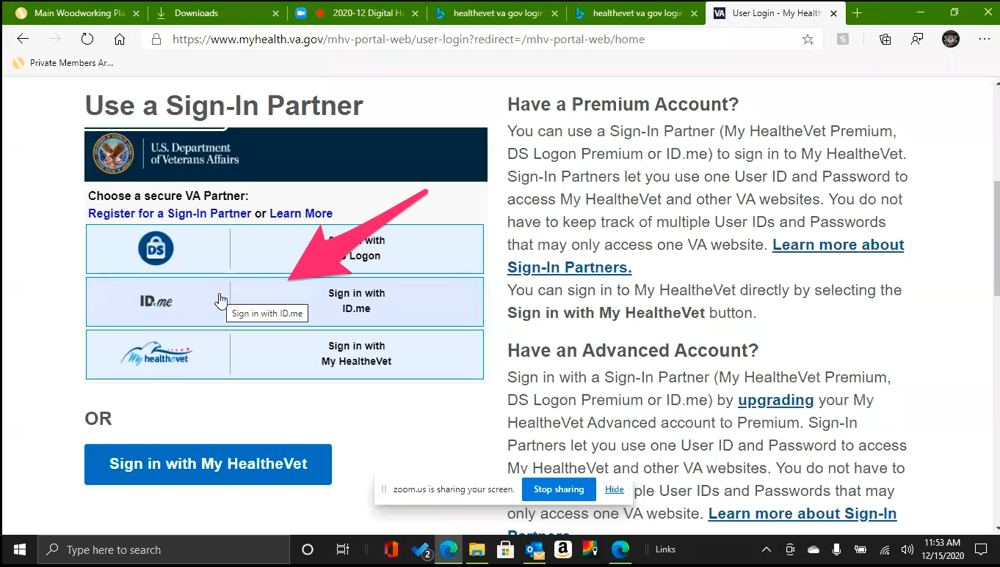

*Participant clicks on [ID.me](http://ID.me) sign in button/area.*

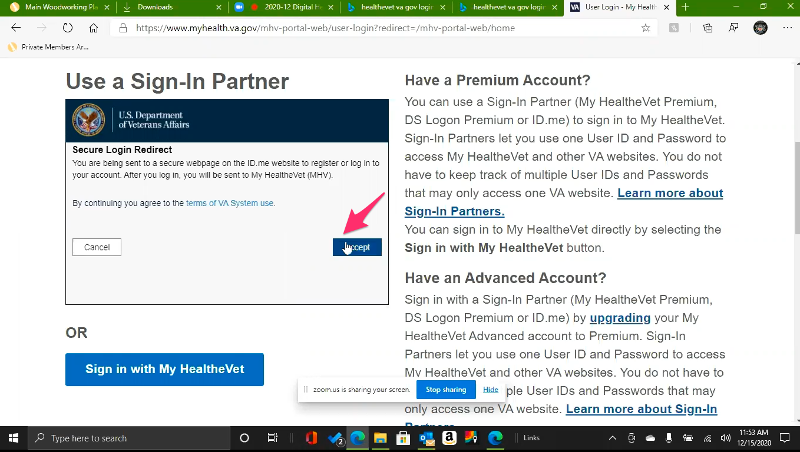

*Secure Login Redirect notice loads. Participant audibly sighs. Says “*Oh Lord. This cant be good.*” Clicks “Accept” button anyway.*

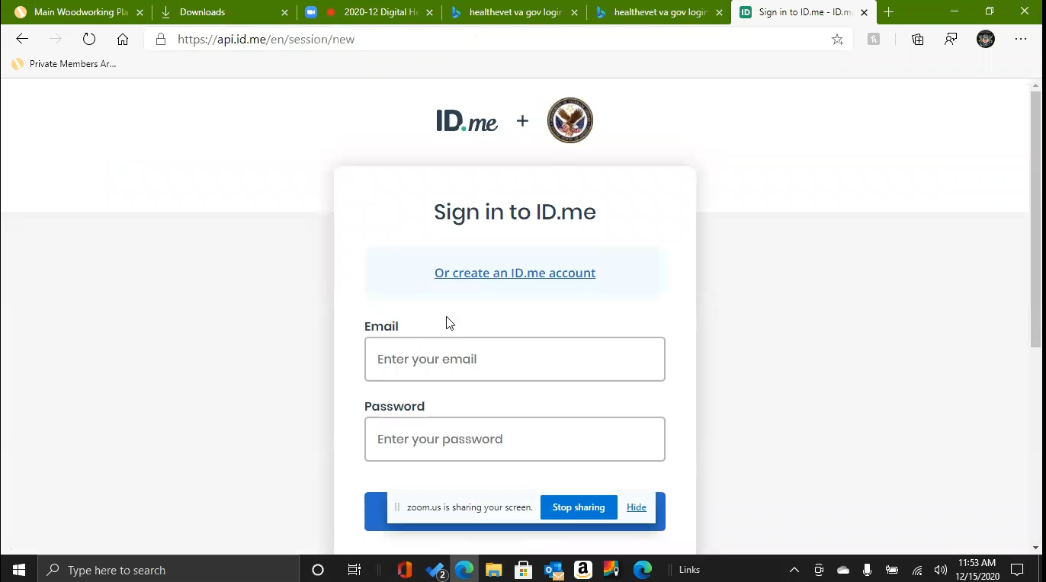

*Participant groans when [ID.me](http://ID.me) site loads.*

Lets see if I have [ID.me](http://ID.me). *Participant shuffles papers.* I don’t think I do. I don’t know. *Participant sighs again.*

*Participant enters in email into Email field. Clicks on Password field.*

Nope doesn't come up. That figures.

1. **Were you hoping the password was saved:**

Yes. It probably isn’t, oh here it is. Look at that! Probably older than dirt so.

*Participant enters in password and clicks “Continue”.*

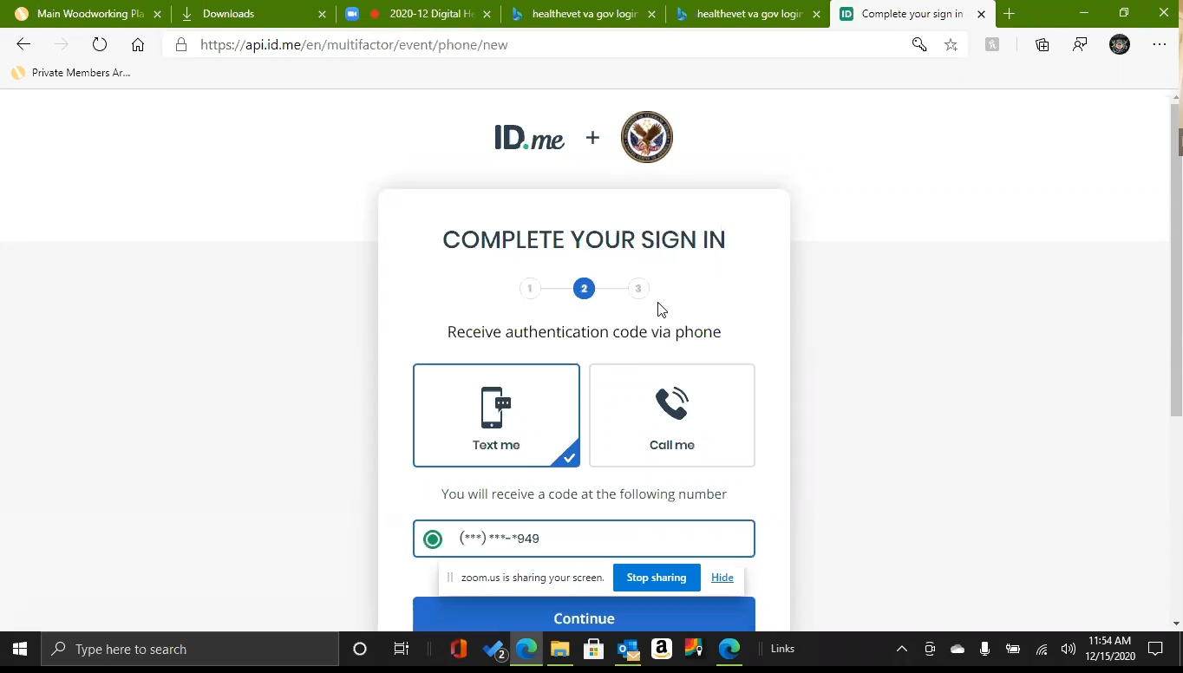

*Participant gets promoted to get authentication code to finish login. This doesn’t phase them at all or cause any hesitation on what to do so it must be a process they are familiar with.*

Ok where's my phone.

*Participant enters in code from text on cell phone and clicks continue button. Successfully signs in.*

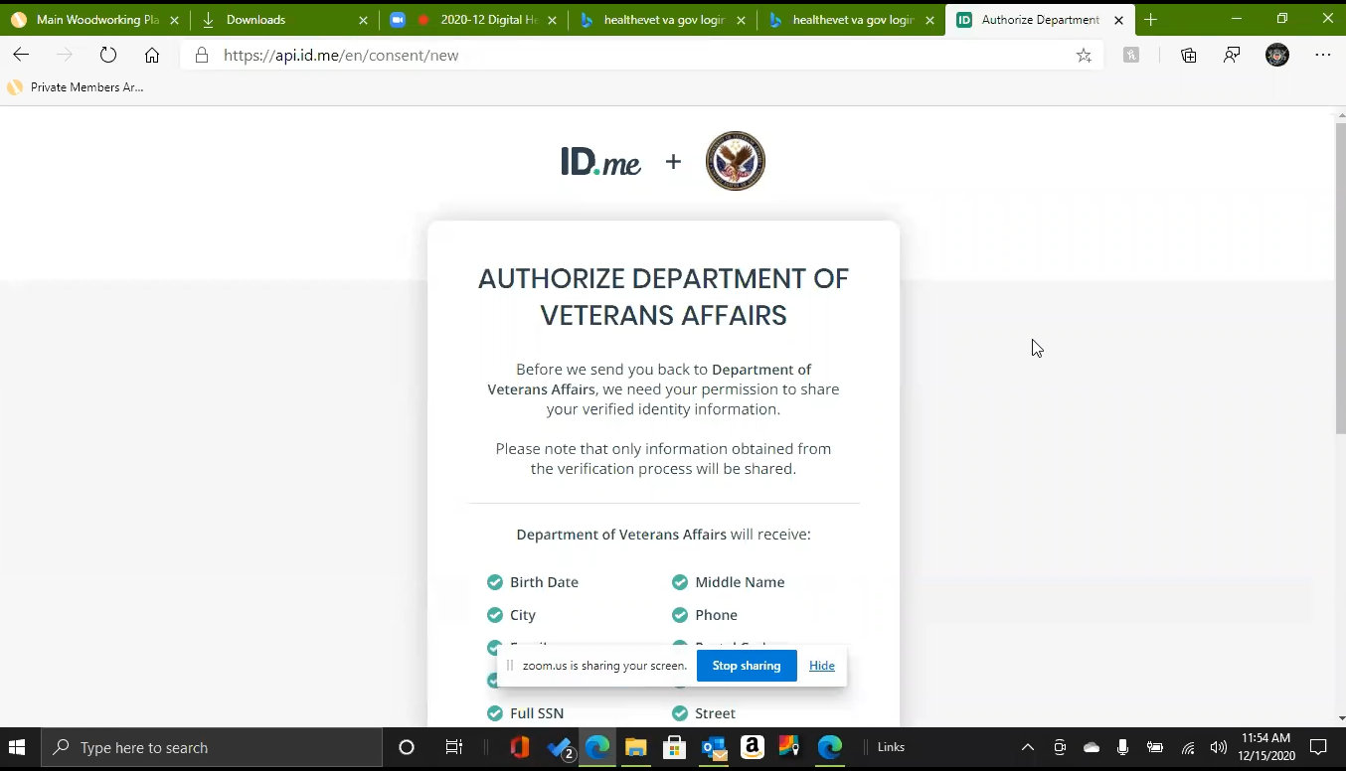

*Participant gets confirmation to share information from [ID.me](http://ID.me) with the VA.*

Okay, are you seeing what you need to see?

**Yep. What is this looking like its asking you for**:

To authorize the VA to share the information. (reading screen), I would assume they already had that but what do I know.

*Participant clicks “Allow” button.*

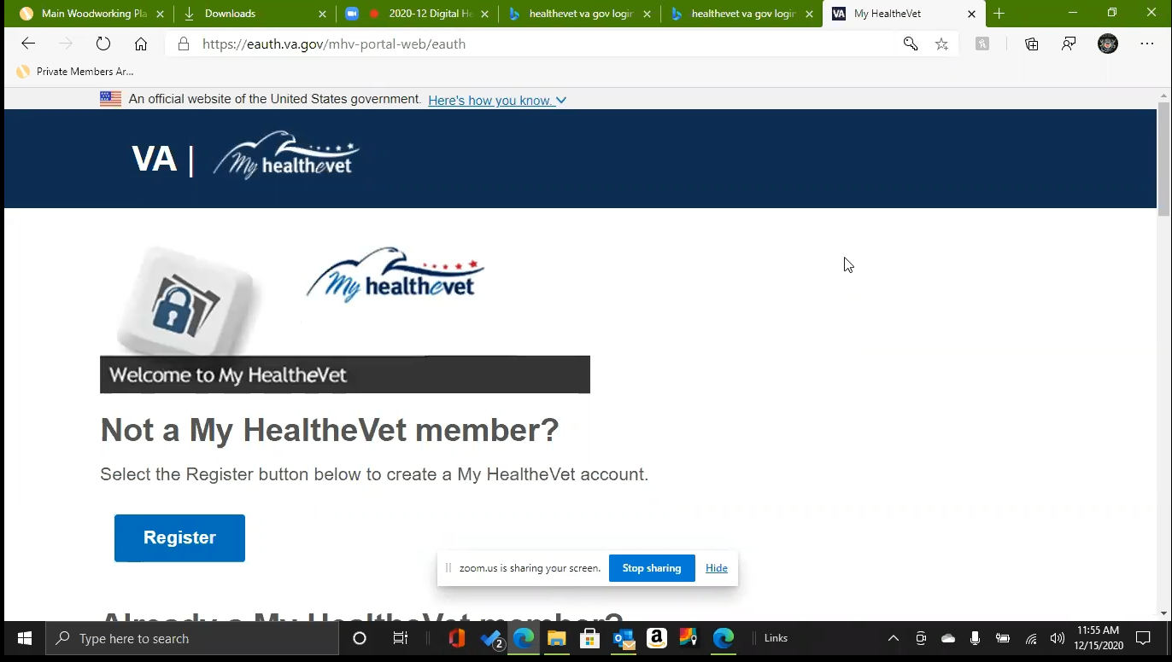

*Participants page after sign in with ID.me.*

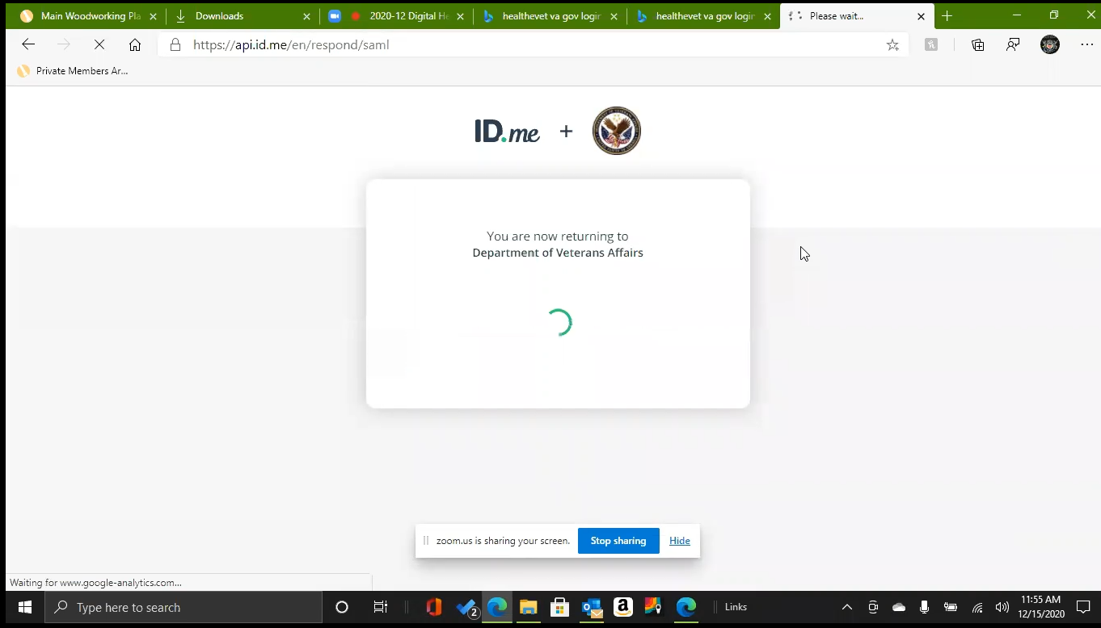

*Page loads for several seconds.*

**What does this look like it is saying:**

To enter your your HealtheVet user id which I am sure that’s not it. *Participant is referring to User ID field having been autofilled by browser.*

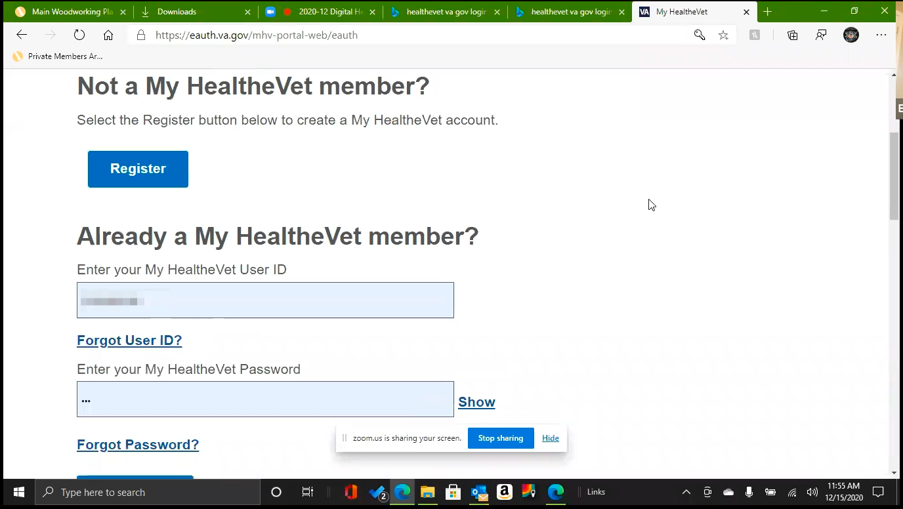

*Participant is focused on “Already a My HealtheVet member?" login. Did not appear to notice or consider the Register section above it.*

And also the password. *Participant shuffles papers.* I don’t know why they want that. It is probably a two party authentication. I am pretty sure.

I don’t know if this is. *Participant presumably looks at papers for several seconds.*

Do you want me to find out what my user id is?

1. **I think that’s ok since we have a few more minutes. Do you remember what did on My HealtheVet:**

I think it was just curiosity of why I could get on it. To see what it does. That would be the biggest thing.

I keep getting newsletter from My Health Vet telling me what the VA does but I don’t think 9 out of 10 times I am not qualified to access it but I do get an email from My Health Vet every three weeks or month.

1. **Do you find that newsletter that valuable:**

Yes, especially the COVID. Us as non-medical people, any information is good information if it is coming from a viable source.

There are things in there like stop smoking, something about orthopedics, my knees are shot but I usually get up first thing in the morning, get coffee, clear email, and do what I do around here so I don’t take time. I just look at it.

**Thank you and closing (2 minutes)**

Feedback: If you are a people person trying to, I was big into boats so computers weren’t my thing. Most retirees trying to get on a VA type thing, web page I guess. Make it simple, simple words, simple sentences for simple people. I’m not trying to say that as derogatory. There are some things we don’t comprehend as well as you young folks. You are the way of the world now, your rarely see a 60 year old guy as a computer gizmo guy. Every now again you do, but for the part you see you young guys.

*After a fair amount of frustration with screen sharing the participant was upbeat at the end and seemed happy to have helped and participate.*